March 2021
Collier Metropolitan Planning Organization
IN MOTION

What’s New at the MPO?

THE DRAFT FY 22-26 TRANSPORTATION IMPROVEMENT PROGRAM (TIP) HAS BEEN UPDATED TO MATCH THE APRIL RELEASE OF THE FDOT WORK PROGRAM
The Technical and Citizens Advisory Committees will finalize their review of the draft TIP on May 24, 2021. The MPO Board will take action on the TIP at their meeting on June 11, 2021.
-MEMBERS OF THE PUBLIC ARE INVITED TO COMMENT-

VIEW THE DRAFT FY22-26 TIP HERE
Call or send comments and questions directly to the MPO Director at:
239-252-5884
Anne.mclaughlin@colliercountyfl.gov

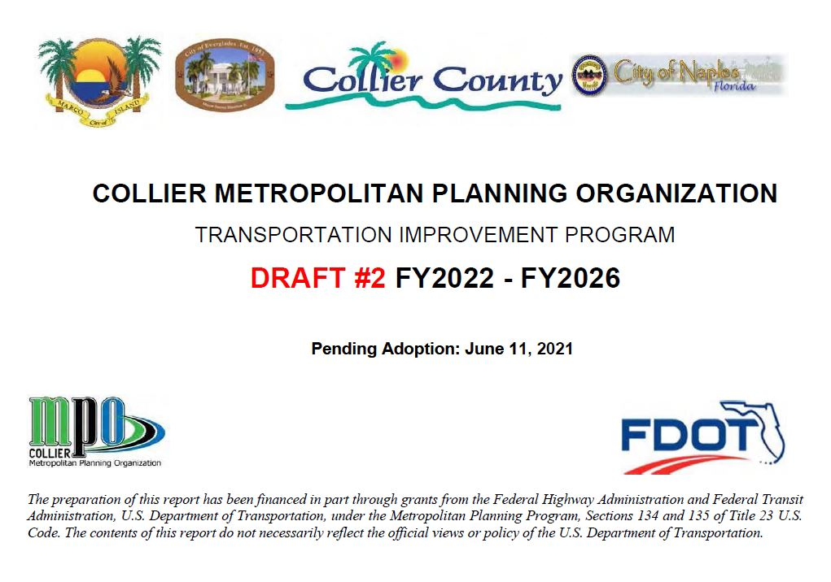

We have vacancies to fill on the Bicycle and Pedestrian Advisory Committee and the Citizens Advisory Committee
Click here to apply: https://www.colliermpo.org/wp-
content/uploads/2020_MPO-Advisory-Committee-
Application.pdf
Or call the MPO Director, Anne McLaughlin at 239-252-5884 for more information.

VIEW THIS MONTH’S BIKE/PED SAFETY VIDEO:
https://www.youtube.com/watch?v=X1q8VAkBE5E

DRAFT TRANSPORTATION DISADVANTAGED SERVICE PLAN
(TDSP)
MINOR UPDATE
Posted for Public Comment

VIEW THE DRAFT TDSP at this link: https://www.colliermpo.org/wp-content/uploads/2021/04/DRAFT-TDSP-2021-Minor-Update.pdf
Call or send comments and questions directly to:
Brandy Otero, MPO Principal Planner
239-252-5859
Brandy.Otero@colliercountyfl.gov

Contact Collier MPO Office at 239- 252-5814 or via email at: colliermpo@colliercountyfl.gov
WWW.COLLIERMPO.ORG
